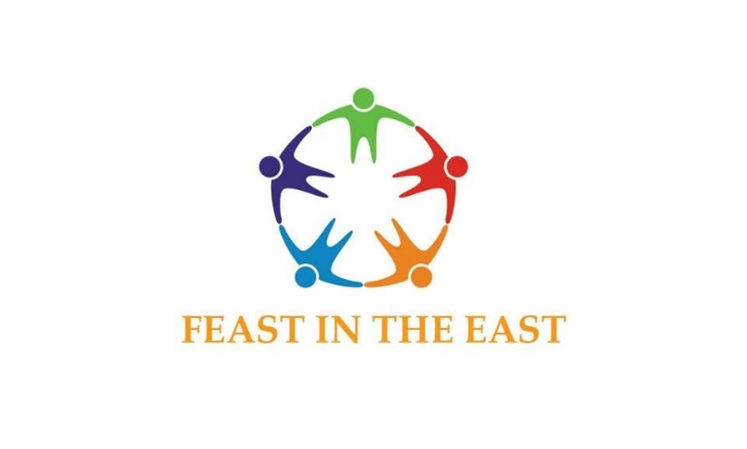

be apart of a unique opportunity… WE ARE better together
Our History…
Around Thanksgiving 2016, East Waco native Rocky Miller, posted a status on his Facebook page. On it, Miller reflected on the things he was grateful for as well as pondered on how he could help others. When Miller posted the status, he "got such a response and so many saying let's do it and once I saw the response it was one of those tasks that choose me."
So, Miller got to work, reaching out to people who had expressed an interest in helping and other organizations in the community. After numerous conference calls and outreach, Miller decided on the Feast in the East.
With the help of Pastor Carlton Stimpson of Open Door Church of God in Christ, Bobby Touchstone, owner of So-So Good Eatery, the alliance endeavored to feed 500 people. In addition, to a home-cooked Christmas Style Dinner with all the fixings they would be handing out gloves, hats, coats, blankets and mid-year school supplies for those who need it.
For Miller, it's not only about giving back but allowing people to interact with each other. He believes many people have a bad impression of the East Waco area. He hopes the event, open to everyone, will shine a different light on the neighborhood.
"I want to invite people who have means and support to meet those people in the community that may not. It's a wonderful community and place I'm proud of," he said.
This year is another opportunity to pool our resources and efforts for this outstanding cause. Feast in the East will be held on Thursday, December 23, 2021 at the City of Waco Multi-Purpose Center located at 1020 Elm Avenue on the Historic Paul Quinn Campus in East Waco from 2 pm - 6 pm.

Sponsorship opportunities available in five (5) Levels:

ENDLESS-FEAST SPONSORSHIP / MEGA-FEAST SPONSORSHIP

SUPER-FEAST SPONSORSHIP / GRAND-FEAST SPONSORSHIP

FRIEND OF THE FEAST IN THE EAST

ENDLESS-FEAST SPONSOR $15,000 donation
As the ENDLESS FEAST SPONSOR your package includes:
- Naming/Branding Rights for the entire event
  - “Sponsored by ______________________”
- Location (on-premises) signage
- Exclusive product placement opportunity
- Inclusion of LOGO in all collateral material (no smaller than 2” tall)
- LOGO prominently displayed on volunteer’s keepsake t-shirts (yield 200)
- Inclusion of company name in press releases and broadcast media

MEGA-FEAST SPONSOR $10,000 donation
As the MEGA FEAST SPONSOR your package includes:
- Naming mention in conjunction with promotion of Feast in the East
- Location (on-premises) signage
- Inclusion of LOGO in all collateral material (no smaller than 1” tall)
- LOGO prominently displayed on volunteer’s keepsake t-shirts (yield 200)
- Inclusion of company name in press releases and broadcast media

SUPER-FEAST SPONSOR $5,000 donation
As the SUPER FEAST SPONSOR your package includes:
- Inclusion of LOGO in all collateral material (no smaller than 1” tall)
- LOGO prominently displayed on volunteer’s keepsake t-shirts (yield 200)
- Inclusion of company name in press releases and broadcast media

GRAND -FEAST SPONSOR $2,500 donation
As the GRAND FEAST SPONSOR your package includes:
- Inclusion of LOGO in all collateral material (no smaller than 1” tall)
- LOGO prominently displayed on volunteer’s keepsake t-shirts (yield 200)
- Inclusion of company name in press releases and broadcast media, as feasible

FRIENDS OF THE FEAST IN THE EAST $250 - $2,499 donation
- LOGO displayed on volunteer’s keepsake t-shirts (yield 200)
- Inclusion of company name in press releases and broadcast media, as feasible

We thank you for sharing our enthusiasm and taking advantage of this marvelous opportunity.
For more information, or to customize your sponsorship package, please contact:
Keshia Miller  East Waco Empowerment Project  Email: ewepinformation@gmail.com  605 Austin Avenue  Waco, TX 76701  254-292-2423 | Rocky Miller  Founder of Feast in the East  Email: ewepinformation@gmail.com  605 Austin Avenue  Waco, TX 76701  254-315-6233

